**Assignment 3**

1. What is the main difference between a class and an object?

A class is a blueprint from which you can create the instance, i.e., objects whereas an object is the instance of the class, which helps programmers to use variables and methods from inside the class.

A class is used to bind data as well as methods together as a single unit whereas object acts like a variable of the class.

1. What is Encapsulation? Explain with a used case.

Encapsulation is the process of hiding information details and protecting data and behaviour of an object from misuse by other objects.

 Encapsulation is used to hide the values or state of a structured data object inside a class, preventing unauthorized parties’ direct access to them. Publicly accessible methods are generally provided in the class to access the values, and other client classes call these methods to retrieve and modify the values within the object.

1. What is Polymorphism? Explain with a used case

Polymorphism is an object-oriented programming concept that refers to the ability of a variable, function or object to take on multiple forms.

A variable with a given name may be allowed to have different forms and the program can determine which form of the variable to use at the time of execution

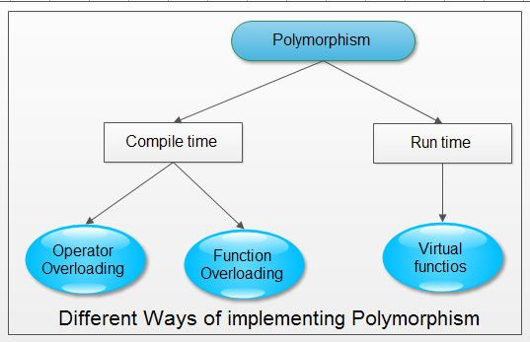

1. Explain Overriding & Overloading and its advantages.

**Overriding:**

Method overriding means defining a method in a child class that is already defined in the parent class with the same method signature i.e same name, arguments, and return type.

Whenever we extend a super class in a child class, the child class automatically gets all the methods defined in the super. We call them derived methods. But in some cases, we do not want some derived methods to work in the manner that they do in the parent. We can override those methods in the child class.

**Overloading:**

Method overloading means providing two separate methods in a class with the same name but different arguments, while the method return type may or may not be different, which allows us to reuse the same method name.

There are some rules for method overloading

1. Both must have the same method name.
2. Both must have different argument lists.